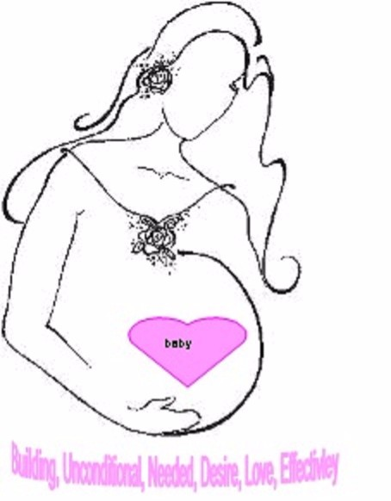
LADIES OF POWER WOMEN’S MINISTRY
7311 San Pablo Dr.
Houston, TX.77083
832-582-4567
ladiesofpowerministry@gmail.com
www.ladiesofpower.weebly.com

Bundle of Joy Program - Adding a Bundle

Adding a Bundle
If this is not your first baby, Ladies of Power will still love to bless you. Ladies of Power will bless you with a Bundle of Joy Care Package for your new bundle of joy. Please submit the application below. We understand that when a new baby is added to your family the balance is thrown off just a little. With applying for the not my first baby we offer a 1 time class you can participate within. The board will view all applications and will contact you once a decision is made. Please read all rules and sign the application before submitting it back to the program.

We'll bless you with a one time donation for your new bundle of Joy. Once this part of the program grows even more we’ll be able to offer more throughout the year for those mothers who may need a little more assistance throughout the year.

LADIES OF POWER WOMEN’S MINISTRY
7311 San Pablo Dr.
Houston, TX.77083
832-582-4567
ladiesofpowerministry@gmail.com
www.ladiesofpower.weebly.com

Greetings,

We thank you for desiring to apply for our community outreach program. This is a program for mothers who are adding a new bundle of joy to the family. During this one time donation we’re asking for all mothers to attend a 1 time class offered by the program. This class will help you readjust the family to the new bundle of joy as well as spiritually. The class will be offered through a distance class form. Once you have applied for the program you will receive all the information for the class. Please read all the rules and qualifications before submitting your application. You may apply even if your baby has arrived or before your baby arrives.

Again we thank you for allowing us to be a blessing in your life,

Sincerely,

Ladies of Power and the Bundle of Joy Program Director

LADIES OF POWER WOMEN’S MINISTRY
7311 San Pablo Dr.
Houston, TX.77083
832-582-4567
ladiesofpowerministry@gmail.com
www.ladiesofpower.weebly.com

Qualifications: You must complete the application and return and signed
You must submit a summary of your situation to the board
You must have one or more of the following assistance: Medicaid, Snap
(Food Stamps) Chip, or WIC - Send in proof of 1
This must be your second plus child being added to the family
You must have a major loss of income - show proof by providing 2 paycheck stubs
or a written letter from job that time is given off without pay

Rules:
- If you are selected to receive the Bundle of Joy Care Package you must send a thank you card
or email
- You must attend the 1 time class: Rebalancing the family
- You must meet all the qualifications listed above
- Class and thank you card/email must be completed before you receive the Bundle of Joy Care Package
- If you unable to complete the class you must contact the Bundle of Joy Program Director
- You may apply once every 7 months until your baby reaches 1 years old, If your baby has reached the age 1 and you need assistance with something you must contact the Bundle of Joy Director via Email: ladiesofpowerministry@gmail.com att. BOJP- Director
- Make sure all information given is printed or typed. Ink color black or blue only
- Please print all pages for your records.
- Send in only the Application Pages labeled: Application

LADIES OF POWER WOMEN’S MINISTRY
7311 San Pablo Dr.
Houston, TX.77083
832-582-4567
ladiesofpowerministry@gmail.com
www.ladiesofpower.weebly.com

Application- Adding a Bundle
Please print in Black or Blue Ink, or Type

Parent Information:

Mother

Name:____________________________________ DOB:__________________
( Last, First, Middle Initial) 00/00/0000

Mailing Address:_____________________________________________

__________________________________________________________ County:___________

Email:_______________________________________ Contact Number:_________________

Are you working or will be working: YES or NO

Father
Name:________________________________________ DOB:__________________
(Last, First, Middle Initial) 00/00/0000

If Different from above:
Mailing Address:_______________________________ County:_____________

________________________________________________________
Are you working or will be working: YES or NO
LADIES OF POWER WOMEN’S MINISTRY
7311 San Pablo Dr.
Houston, TX.77083
832-582-4567
ladiesofpowerministry@gmail.com
www.ladiesofpower.weebly.com

Application - Adding a Bundle

Children Information:

Names and DOB of all children living in the household:

1._____________________________ DOB: _____________________

2._____________________________ DOB: _____________________

3._____________________________ DOB: ______________________

4._____________________________ DOB: ________________________

5. _____________________________ DOB: _________________________

If you need to list more children please add them in at the bottom of this page of the application

Due Date of Baby:_________________________ Gender of baby:_________________

If the baby has already arrived

DOB of Baby:__________________ Gender of Baby:__________________

Any additional children please list here with DOB and name:

LADIES OF POWER WOMEN’S MINISTRY
7311 San Pablo Dr.
Houston, TX.77083
832-582-4567
ladiesofpowerministry@gmail.com
www.ladiesofpower.weebly.com

APPLICATION-Adding a Bundle
Summary

Please explain to the board on why you need assistance and list any small items you may need the most.

LADIES OF POWER WOMEN’S MINISTRY
7311 San Pablo Dr.
Houston, TX.77083
832-582-4567
ladiesofpowerministry@gmail.com
www.ladiesofpower.weebly.com

APPLICATION - ADDING A Bundle
Check List

- All pages of the application has been filled out correctly
- Printed in Black or Blue Ink, or Typed
- Written a Summary and attached to application
- Write your last name and DOB on each application page
- Sign and date the check list page and attach to application
- I have attached all forms of proof with state assistance/loss of income

I fully understand all terms and conditions of the program and all information I have provided is correct. Please understand your information will not be shared with anyone but the board for this program.

Signature:________________________________________ Date:__________________
(Your Name)

Signature:________________________________________ Date:__________________
( Spouse Name)

